Exercise 2: E-commerce Platform Search Function
using System;
interface ISearch
{
void Search();
}
class ProductSearch : ISearch
{
public void Search()
{
Console.WriteLine("Searching for products...");
}
}
class CategorySearch : ISearch
{
public void Search()
{
Console.WriteLine("Searching by category...");
}
}
class SearchFactory
{
public static ISearch GetSearch(string searchType)
{
if (searchType.ToLower() == "product")
return new ProductSearch();
else if (searchType.ToLower() == "category")
return new CategorySearch();
else
return null;
}
}
class Program
{
static void Main()
{
Console.Write("Enter search type (product/category): ");
string type = Console.ReadLine();
ISearch search = SearchFactory.GetSearch(type);
if (search != null)
search.Search();
else
Console.WriteLine("Invalid search type.");
}
}
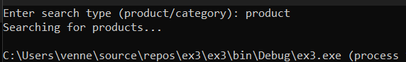
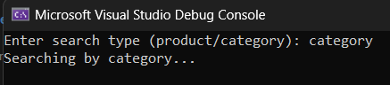

Exercise 7: Financial Forecasting
using System;
class FinancialForecast
{
static double Forecast(double amount, double rate, int years)
{
if (years == 0)
return amount;

return Forecast(amount, rate, years - 1) * (1 + rate / 100);
}
static void Main()
{
Console.Write("Enter initial amount: ");
double amount = Convert.ToDouble(Console.ReadLine());
Console.Write("Enter annual growth rate (%): ");
double rate = Convert.ToDouble(Console.ReadLine());
Console.Write("Enter number of years: ");
int years = Convert.ToInt32(Console.ReadLine());
double futureValue = Forecast(amount, rate, years);
Console.WriteLine("Forecasted value after " + years + " years: " +
futureValue.ToString("F2"));
}
}

